2.40: Using Eq. (2.13), with downward velocities and accelerations being positive,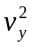 = (0.8 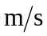)² + 2(1.6 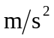)(5.0 m) = 16.64 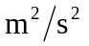 (keeping extra significant figures), so v_{y} = 4.1 .

